Day 1 January 31

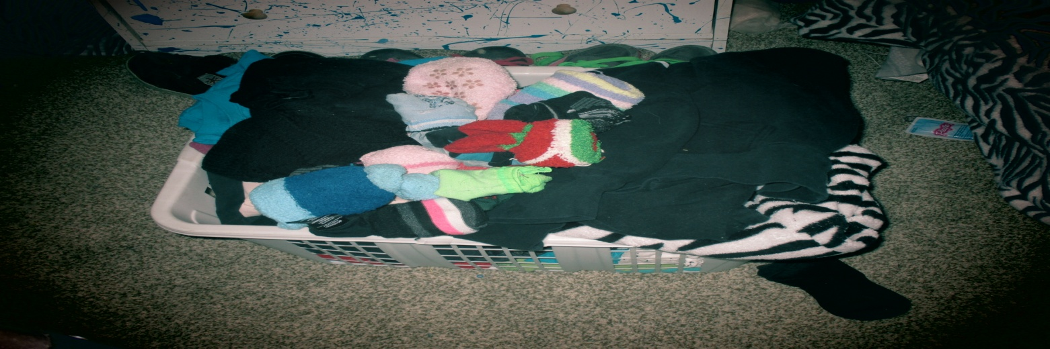

So this basket of clean laundry took me 20 minutes to unload. It felt like it took forever because i had no music on

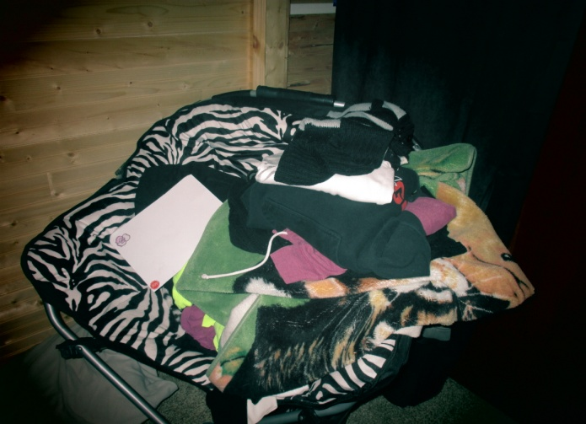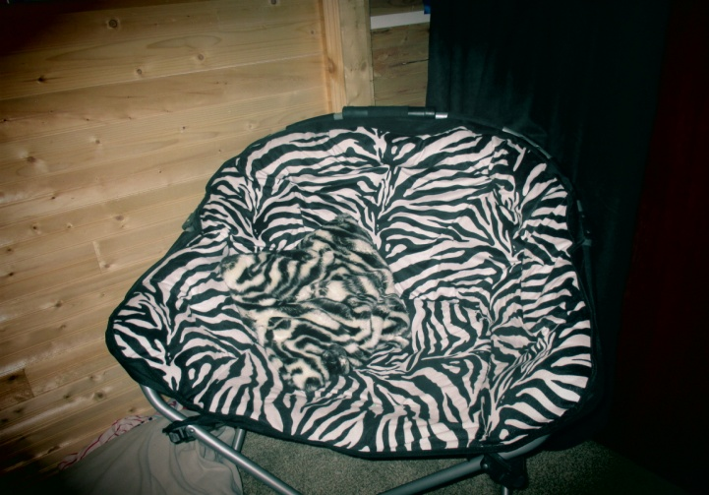

This chair of clean laundry and blankets took about 20 minutes to do. It felt like so much work because I kept getting distracted.

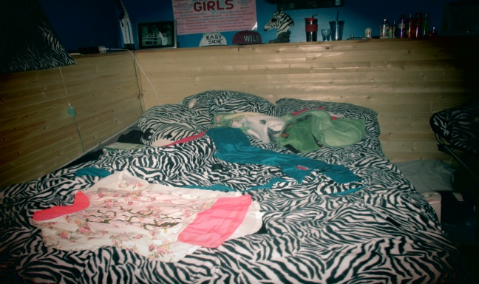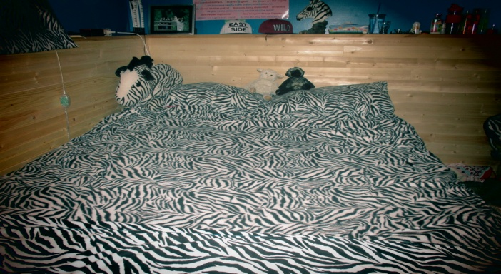

It took me 15 minutes to change my sheets and clean all of the junk out of it.

Overall cleaning my room today took around 1 hr and 5 minutes to do. It felt like it took forever and I was super tired but i think next I will listen to some music and that should make it a bit more enjoyable. Even though it felt like a pain in the butt to do I`m glad I did it before things got worse.

Day 2 February 2

So today I cleaned off my dresser, desk and other stuff around it. That took me 10 minutes to do. It was pretty cluttered so I figured it was due time. I also had another load of clean laundry to put away and it only took half of the time as it did yesterday! I think that the music really helped me get into the cleaning mood.

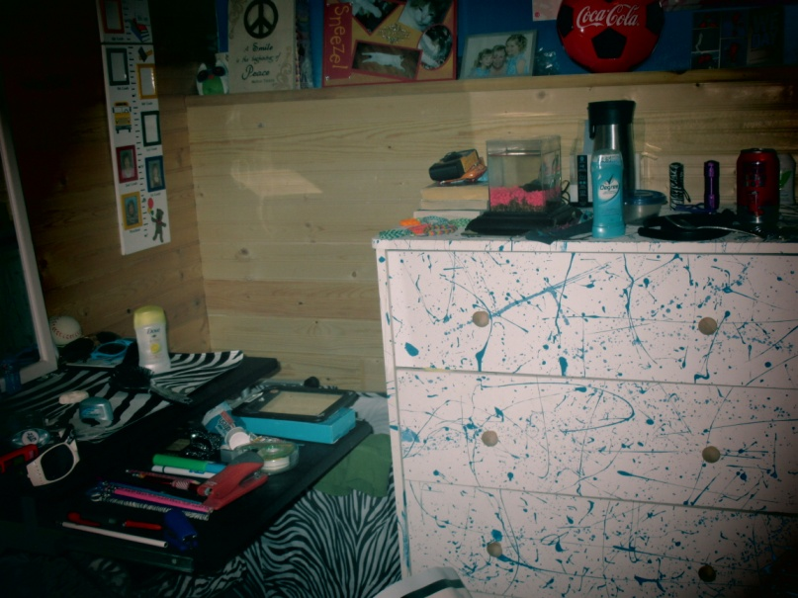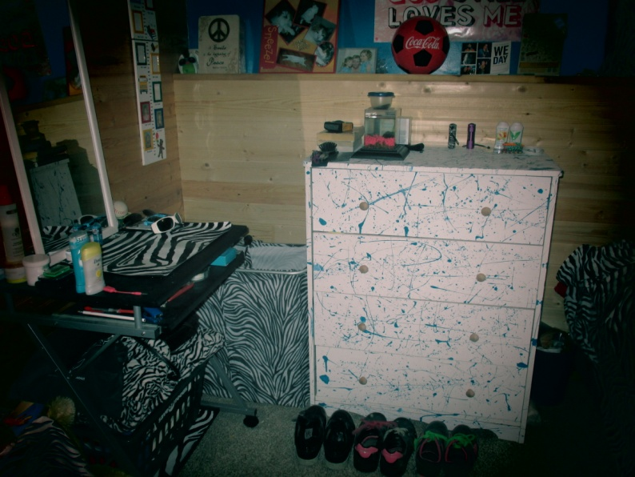

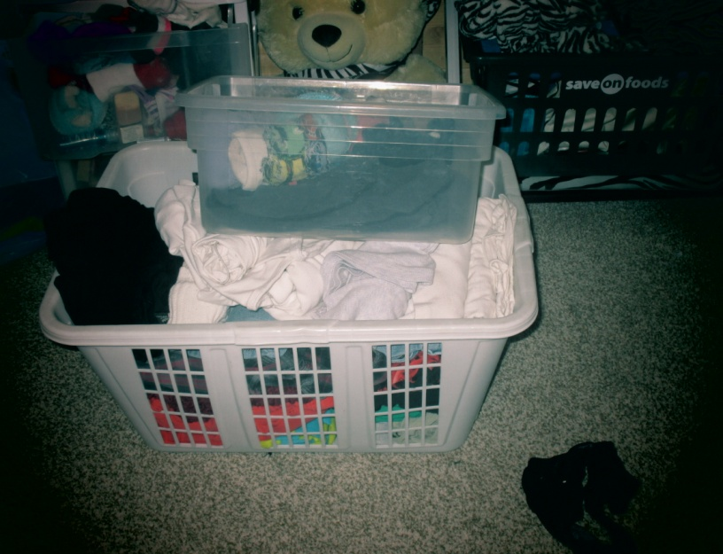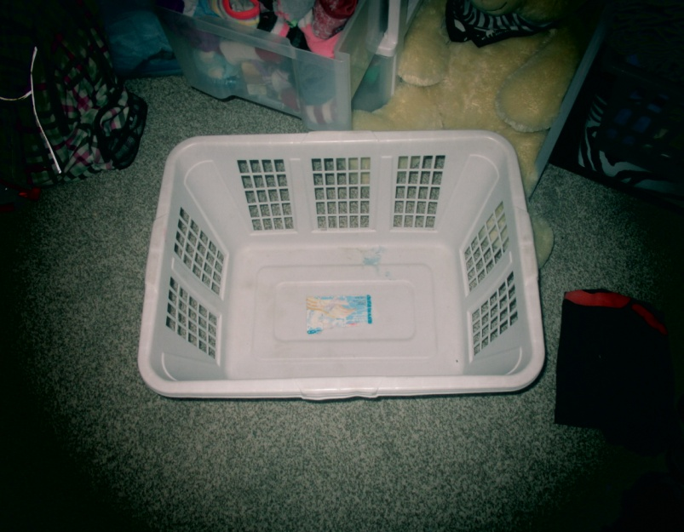

Day 3 February 10

So today I decided that my bed was getting pretty messy so I cleaned that off and it only took 10 minutes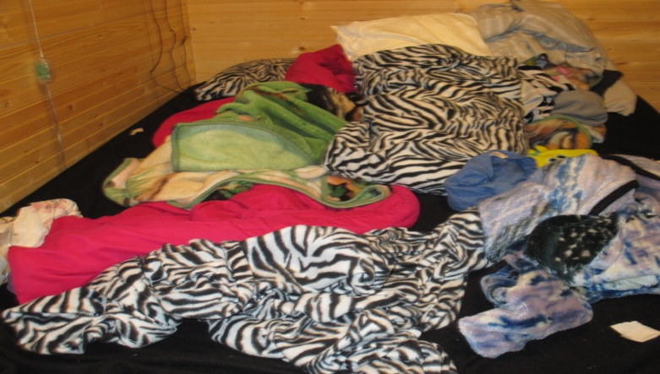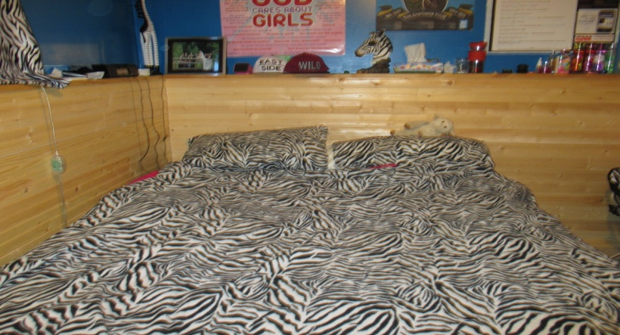

Day 4 February 18

So today I had quite a bit of clean laundry to but away, I had a basket and my chair full of laundry. These two put togather only took 20 mins.

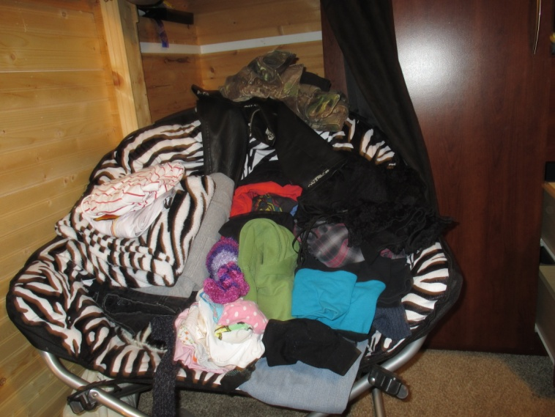

Closing Entry

So I am actually quite glad that I chose this as my project. This has made me more successful because even though I didn`t record it, whenever I took off my clothes I put them into my dirty hamper and the floor basically stayed pretty clean the whole time and now it`s just kind of a habit of keeping everything tidied. I also found out that I work a lot faster with music. After a while it didn`t even seem like a chore anymore it was actually kind of fun because I got to listen to music really loudly and just forget about everything else.